Database Design
ER DIAGRAM:
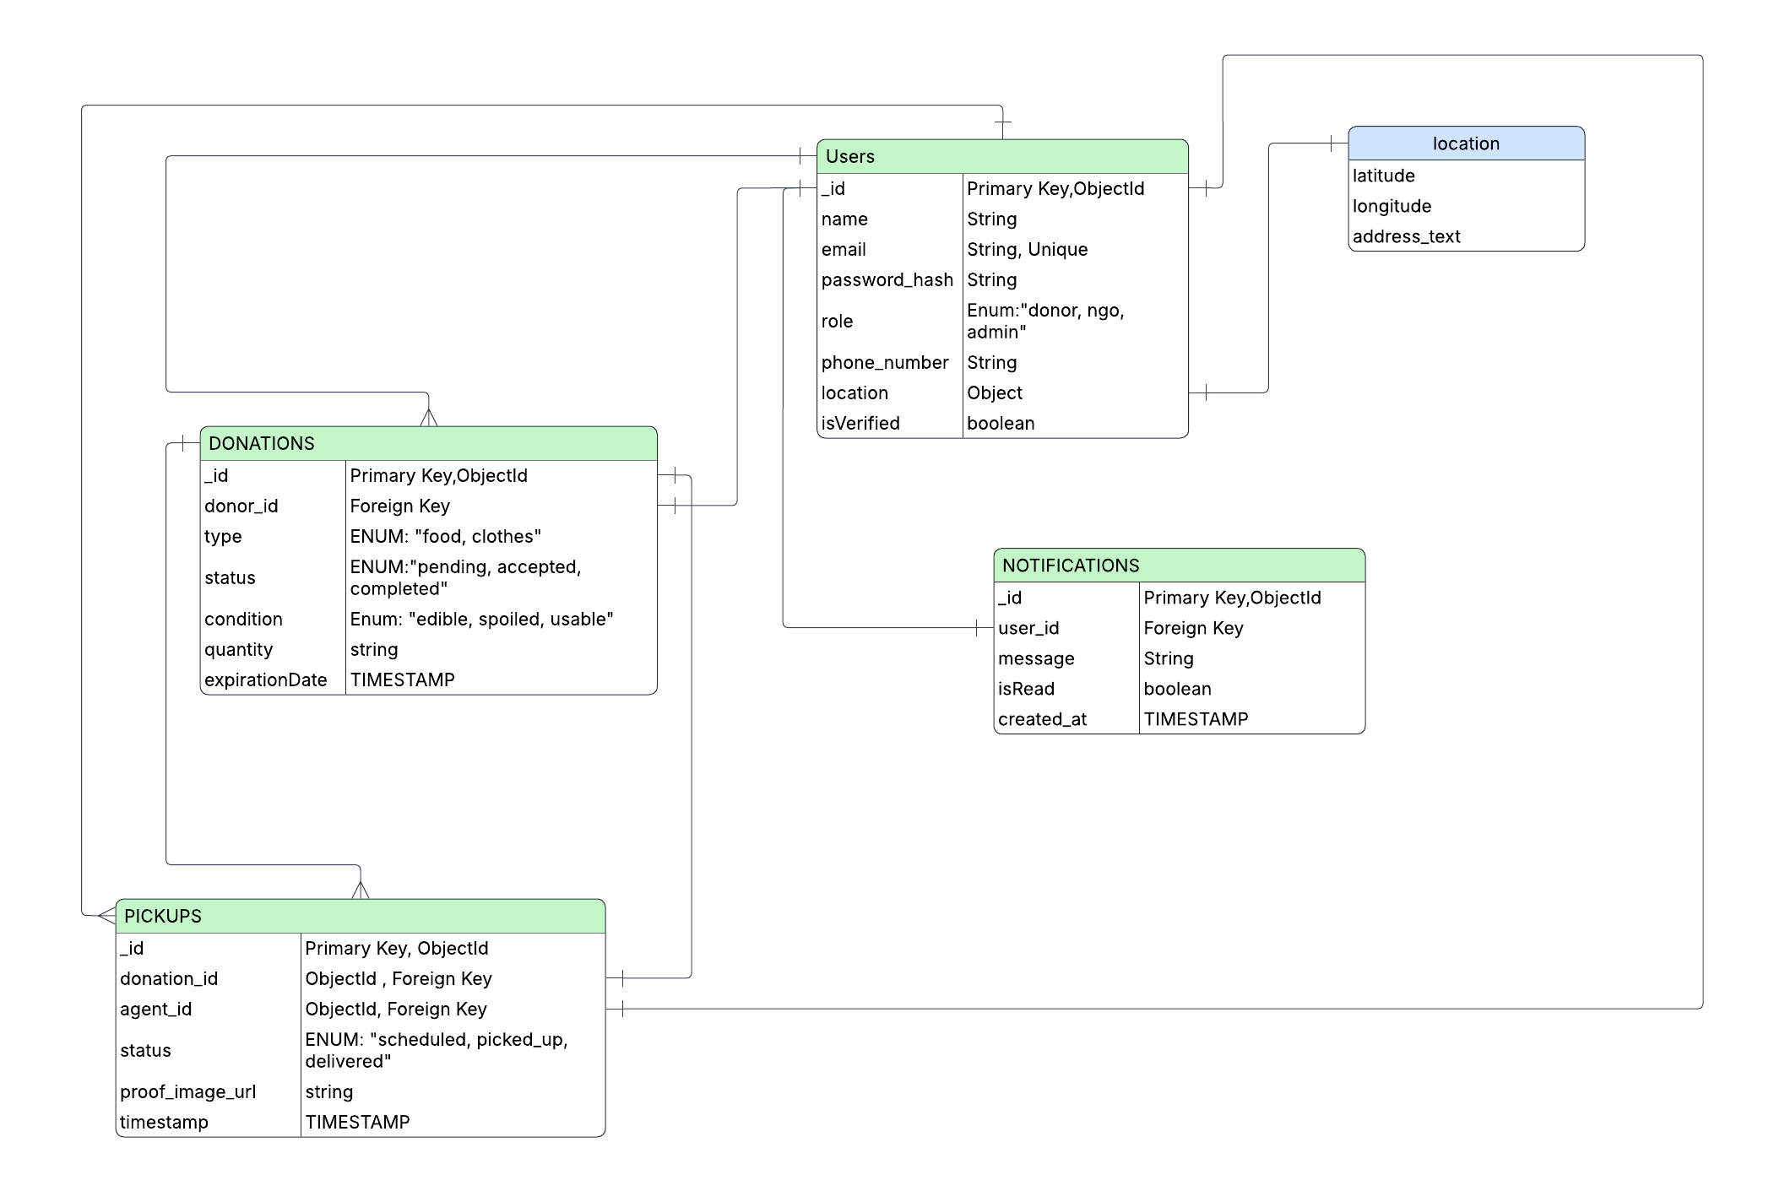

Schema Implementation:

0. Shared Schema: Location

const LocationSchema = new mongoose.Schema({
latitude: { type: Number, required: true },
longitude: { type: Number, required: true },
address_text: { type: String, required: true }
}, { _id: false });

1. Users Collection
const UserSchema = new mongoose.Schema({
name: { type: String, required: true },
email: {
type: String,
required: true,
unique: true,
index: true
},
password_hash: { type: String, required: true, select: false },
phone_number: { type: String, required: true },

role: {
type: String,
enum: ['donor', 'ngo', 'admin'], // Strictly matching diagram enums
default: 'donor'
},
location: { type: LocationSchema, required: true },
isVerified: { type: Boolean, default: false }
}, { timestamps: true });

2. Donations Collection

const DonationSchema = new mongoose.Schema({
donor_id: {
type: mongoose.Schema.Types.ObjectId,
ref: 'User',
required: true,
index: true
},
type: {
type: String,
enum: ['food', 'clothes'],
required: true
},
status: {
type: String,
enum: ['pending', 'accepted', 'completed'],
default: 'pending',
index: true
},
condition: {
type: String,
enum: ['edible', 'spoiled', 'usable'],
required: true
},
quantity: { type: String, required: true }, // e.g., "10kg" or "2 bags"
expirationDate: { type: Date } // Matches 'TIMESTAMP' from diagram
}, { timestamps: true });

3. Pickups Collection

const PickupSchema = new mongoose.Schema({
donation_id: {
type: mongoose.Schema.Types.ObjectId,
ref: 'Donation',
required: true
},
agent_id: {
type: mongoose.Schema.Types.ObjectId,
ref: 'User',
required: true
},
status: {
type: String,
enum: ['scheduled', 'picked_up', 'delivered'],
default: 'scheduled'
},
proof_image_url: { type: String },
timestamp: { type: Date, default: Date.now }
}, { timestamps: true });

4. Notifications Collection

const NotificationSchema = new mongoose.Schema({
user_id: {
type: mongoose.Schema.Types.ObjectId,
ref: 'User',
required: true
},
message: { type: String, required: true },
isRead: { type: Boolean, default: false },
created_at: { type: Date, default: Date.now }
});

